Cabbage moths and butterflies lay their eggs only on plants in the family Brassicaceae. Nearly all cruciferous vegetable crops are attacked, but some are favoured over others. These include broccoli, Brussels sprouts, cabbage, Chinese cabbage, cauliflower, collard, kale, kohlrabi, mustard, radish, turnip, and watercress.

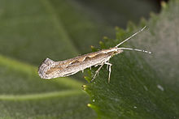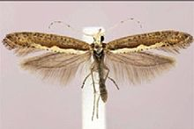
Diamondback Cabbage Moth

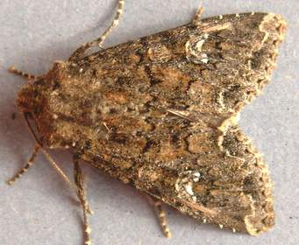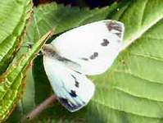
Cabbage moth Small cabbage white butterfly

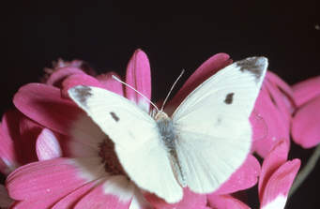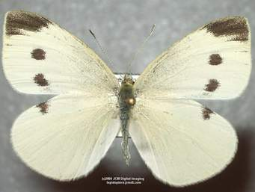
Small cabbage white butterfly Large cabbage white butterfly

